Daily border run & Tour from BANGKOK to Thai/Myanmar border at Kanchanaburi AND Wednesday/Saturday & Sunday to Thai/Cambodia border at Ban Laem too.

- Visa exempt: TWO time 30 days per calendar year (1.1-31.12).
- Join if you activate a new entry of a valid multiple entry Thai Tourist Visa (60 days) or Non Immigrant Visa (90 days).
- Cambodia border stamp Brazil, Russian & South African, transfer stamp from old to new passport possible too.
- Argentina, Chile, Peru & South Korea can NOT stamp there.
- Myanmar border NOT stamp South African & Russian.
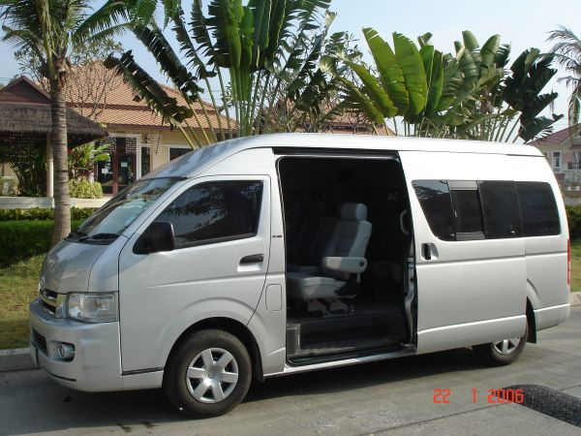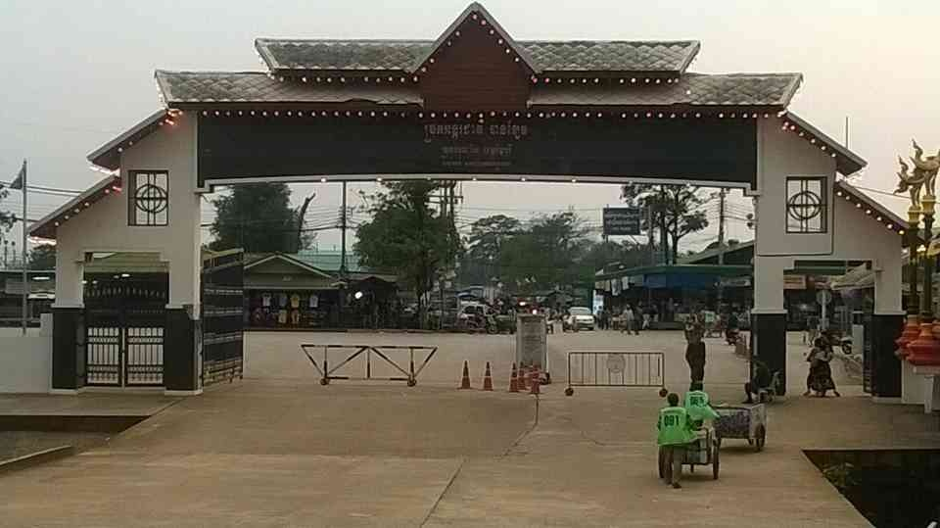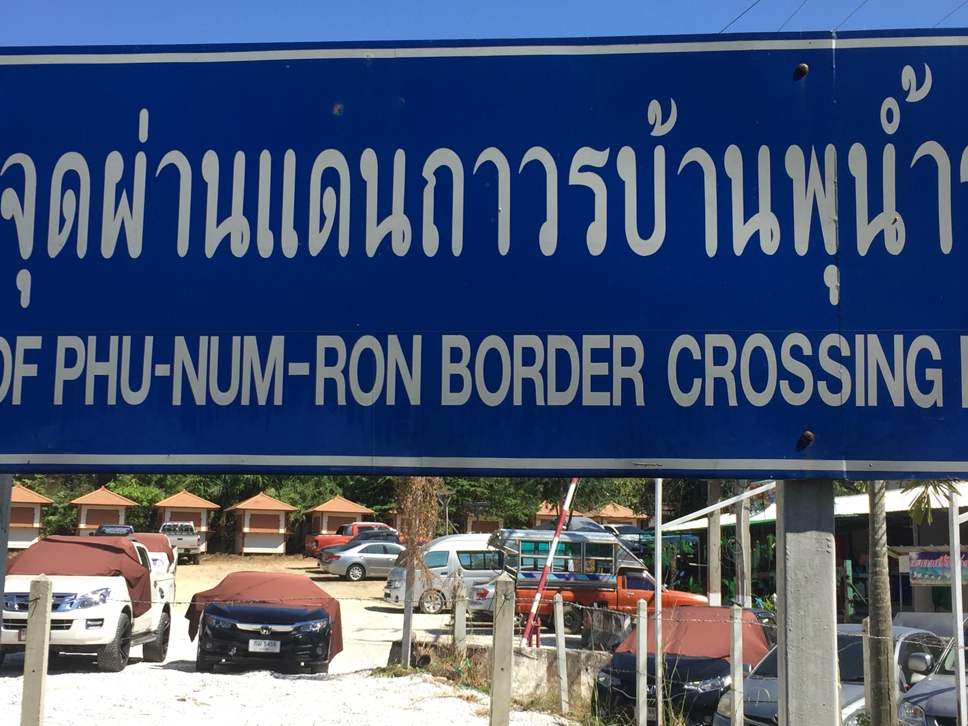

DAILY: For both trips we meet 04:30am, latest departure 05:00am. Parking lot Tesco Lotus, BTS ON NUT, besides KFC. Each way 3-4 hours, one stop each way. At Border we assist, time not exceed 1.5 hour. A small tour to the Famous Bridge over the River Kwai or to a local attraction can be done. Return BTS ON NUT 14:00-15:30.

  - Daily Kanchanaburi/Myanmar (food & tour): THB 2,000.- for Westerners. THB 1,250.- for Filipino.
  - Ban Laem/Cambodia: THB 2,400.- Westerners/Russian. THB 1,200.- for ASEAN.
Include transportation, visa processing, service fees and refreshment.
Tel: 092-5766640 (English & LINE-ID)
thaitouristvisa@gmail.com, www.thaivisaservice.com

